Analisi di contingenza di Cluster_5_15 per label
Diagramma a mosaico
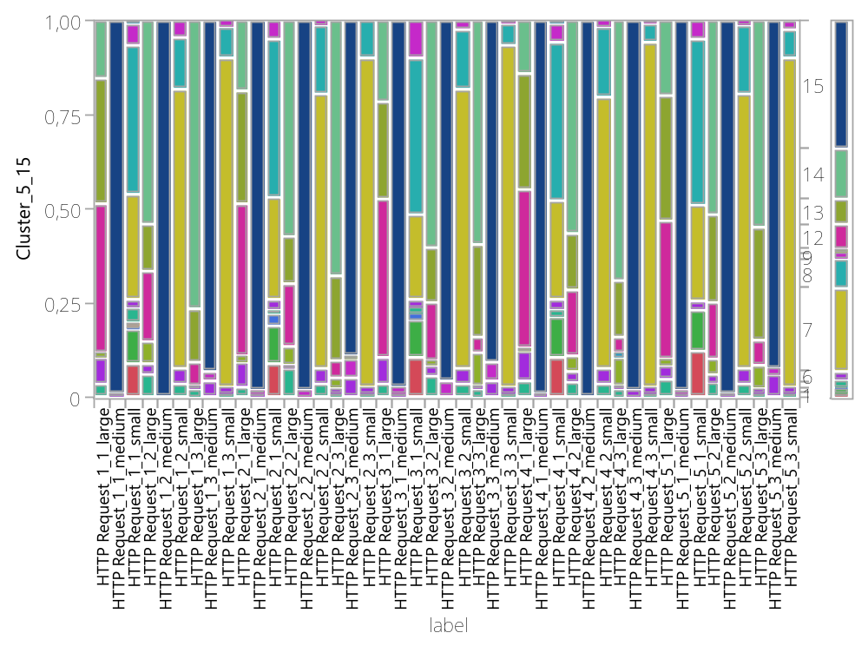

Tabella di contingenza
label Per Cluster_5_15

Conteggio | 1 | 2 | 3 | 4 | 5 | 6 | 7 | 8 | 9 | 10 | 11 | 12 | 13 | 14 | 15 | Totale
HTTP Request_1_1_large | 0 | 0 | 0 | 0 | 4 | 8 | 0 | 0 | 0 | 1 | 0 | 44 | 37 | 17 | 0 | 111
HTTP Request_1_1_medium | 0 | 0 | 0 | 0 | 0 | 1 | 0 | 0 | 0 | 0 | 0 | 0 | 0 | 0 | 119 | 120
HTTP Request_1_1_small | 11 | 11 | 1 | 1 | 5 | 3 | 34 | 48 | 7 | 0 | 1 | 0 | 0 | 0 | 0 | 122
HTTP Request_1_2_large | 0 | 0 | 0 | 0 | 6 | 3 | 0 | 0 | 0 | 6 | 0 | 19 | 13 | 55 | 0 | 102
HTTP Request_1_2_medium | 0 | 0 | 0 | 0 | 0 | 0 | 0 | 0 | 0 | 0 | 0 | 0 | 0 | 0 | 120 | 120
HTTP Request_1_2_small | 0 | 0 | 0 | 0 | 4 | 5 | 89 | 17 | 5 | 0 | 0 | 0 | 0 | 0 | 0 | 120
HTTP Request_1_3_large | 0 | 0 | 0 | 0 | 2 | 1 | 0 | 0 | 0 | 0 | 0 | 6 | 13 | 72 | 0 | 94
HTTP Request_1_3_medium | 0 | 0 | 0 | 0 | 0 | 5 | 0 | 0 | 3 | 0 | 0 | 0 | 0 | 0 | 112 | 120
HTTP Request_1_3_small | 0 | 0 | 0 | 0 | 1 | 2 | 105 | 10 | 2 | 0 | 0 | 0 | 0 | 0 | 0 | 120
HTTP Request_2_1_large | 0 | 0 | 0 | 0 | 3 | 7 | 0 | 0 | 0 | 2 | 0 | 44 | 33 | 20 | 0 | 109
HTTP Request_2_1_medium | 0 | 0 | 0 | 0 | 0 | 1 | 0 | 0 | 1 | 0 | 0 | 0 | 0 | 0 | 118 | 120
HTTP Request_2_1_small | 11 | 12 | 4 | 0 | 1 | 4 | 33 | 51 | 6 | 0 | 0 | 0 | 0 | 0 | 0 | 122
HTTP Request_2_2_large | 0 | 0 | 0 | 0 | 8 | 1 | 0 | 0 | 0 | 5 | 0 | 17 | 13 | 59 | 0 | 103
HTTP Request_2_2_medium | 0 | 0 | 0 | 0 | 0 | 0 | 0 | 0 | 2 | 0 | 0 | 0 | 0 | 0 | 118 | 120
HTTP Request_2_2_small | 0 | 0 | 0 | 0 | 4 | 5 | 88 | 22 | 1 | 0 | 0 | 0 | 0 | 0 | 0 | 120
HTTP Request_2_3_large | 0 | 0 | 0 | 0 | 1 | 1 | 0 | 0 | 0 | 3 | 0 | 4 | 21 | 63 | 0 | 93
HTTP Request_2_3_medium | 0 | 0 | 0 | 0 | 0 | 6 | 0 | 0 | 6 | 1 | 0 | 0 | 0 | 0 | 107 | 120
HTTP Request_2_3_small | 0 | 0 | 0 | 0 | 1 | 2 | 105 | 12 | 0 | 0 | 0 | 0 | 0 | 0 | 0 | 120
HTTP Request_3_1_large | 0 | 0 | 0 | 0 | 4 | 8 | 0 | 0 | 0 | 0 | 0 | 47 | 29 | 24 | 0 | 112
HTTP Request_3_1_medium | 0 | 0 | 0 | 0 | 0 | 1 | 0 | 0 | 2 | 0 | 0 | 0 | 0 | 0 | 117 | 120
HTTP Request_3_1_small | 13 | 12 | 2 | 0 | 2 | 3 | 27 | 51 | 12 | 0 | 0 | 0 | 0 | 0 | 0 | 122
HTTP Request_3_2_large | 0 | 0 | 0 | 0 | 6 | 3 | 0 | 0 | 0 | 1 | 0 | 16 | 15 | 62 | 0 | 103
HTTP Request_3_2_medium | 0 | 0 | 0 | 0 | 0 | 0 | 0 | 0 | 5 | 0 | 0 | 0 | 0 | 0 | 115 | 120
HTTP Request_3_2_small | 0 | 0 | 0 | 0 | 4 | 5 | 89 | 19 | 3 | 0 | 0 | 0 | 0 | 0 | 0 | 120
HTTP Request_3_3_large | 0 | 0 | 0 | 0 | 2 | 1 | 0 | 0 | 0 | 8 | 0 | 4 | 23 | 56 | 0 | 94
HTTP Request_3_3_medium | 0 | 0 | 0 | 0 | 0 | 5 | 0 | 0 | 6 | 0 | 0 | 0 | 0 | 0 | 109 | 120
HTTP Request_3_3_small | 0 | 0 | 0 | 0 | 1 | 2 | 109 | 7 | 1 | 0 | 0 | 0 | 0 | 0 | 0 | 120
HTTP Request_4_1_large | 0 | 0 | 0 | 0 | 5 | 9 | 0 | 0 | 0 | 1 | 0 | 48 | 35 | 16 | 0 | 114
HTTP Request_4_1_medium | 0 | 0 | 0 | 0 | 0 | 1 | 0 | 0 | 0 | 0 | 0 | 0 | 0 | 0 | 119 | 120
HTTP Request_4_1_small | 13 | 13 | 0 | 0 | 2 | 4 | 32 | 51 | 6 | 0 | 1 | 0 | 0 | 0 | 0 | 122
HTTP Request_4_2_large | 0 | 0 | 0 | 0 | 4 | 3 | 0 | 0 | 0 | 4 | 0 | 18 | 15 | 57 | 0 | 101
HTTP Request_4_2_medium | 0 | 0 | 0 | 0 | 0 | 0 | 0 | 0 | 0 | 0 | 0 | 0 | 0 | 0 | 120 | 120
HTTP Request_4_2_small | 0 | 0 | 0 | 0 | 4 | 5 | 87 | 22 | 2 | 0 | 0 | 0 | 0 | 0 | 0 | 120
HTTP Request_4_3_large | 0 | 0 | 0 | 0 | 2 | 1 | 0 | 0 | 0 | 7 | 1 | 4 | 14 | 65 | 0 | 94
HTTP Request_4_3_medium | 0 | 0 | 0 | 0 | 0 | 2 | 0 | 0 | 0 | 0 | 0 | 0 | 0 | 0 | 118 | 120
HTTP Request_4_3_small | 0 | 0 | 0 | 0 | 1 | 2 | 110 | 6 | 1 | 0 | 0 | 0 | 0 | 0 | 0 | 120
HTTP Request_5_1_large | 0 | 0 | 0 | 0 | 5 | 4 | 0 | 0 | 0 | 2 | 0 | 39 | 36 | 21 | 0 | 107
HTTP Request_5_1_medium | 0 | 0 | 0 | 0 | 0 | 1 | 0 | 0 | 1 | 0 | 0 | 0 | 0 | 0 | 118 | 120
HTTP Request_5_1_small | 15 | 13 | 0 | 0 | 0 | 3 | 31 | 53 | 6 | 0 | 0 | 0 | 0 | 0 | 0 | 121
HTTP Request_5_2_large | 0 | 0 | 0 | 0 | 4 | 2 | 0 | 0 | 0 | 4 | 0 | 15 | 23 | 51 | 0 | 99
HTTP Request_5_2_medium | 0 | 0 | 0 | 0 | 0 | 1 | 0 | 0 | 0 | 0 | 0 | 0 | 0 | 0 | 119 | 120
HTTP Request_5_2_small | 0 | 0 | 0 | 0 | 4 | 5 | 88 | 22 | 1 | 0 | 0 | 0 | 0 | 0 | 0 | 120
HTTP Request_5_3_large | 0 | 0 | 0 | 0 | 1 | 1 | 0 | 0 | 0 | 6 | 0 | 6 | 28 | 51 | 0 | 93
HTTP Request_5_3_medium | 0 | 0 | 0 | 0 | 0 | 7 | 0 | 0 | 2 | 0 | 0 | 0 | 0 | 0 | 110 | 119
HTTP Request_5_3_small | 0 | 0 | 0 | 0 | 1 | 2 | 105 | 9 | 3 | 0 | 0 | 0 | 0 | 0 | 0 | 120
Totale | 63 | 61 | 7 | 1 | 92 | 136 | 1132 | 400 | 84 | 51 | 3 | 331 | 348 | 689 | 1739 | 5137

Test

N | DF | -Log verosimiglianza | R-quadro (U)
5137 | 616 | 6031,4781 | 0,6083

Test | Chi-quadrato | Prob>ChiQu
Rapporto di verosimiglianza | 12062,96 | <,0001*
Pearson | 13256,07 | <,0001*

Avvertimento: il 20% delle celle ha un conteggio previsto inferiore a 5, chi-quadrato dubbio.

